logic design 2

Lab1

Name & IDs :
(20011116) كريم فتحي عبد العزيز محمد مصطفى
(20010174) احمد محمد حسن محمد صالح
(20011027)عمر محمود عبد الوهاب السيد
(20011457) محمد احمد علي رياض علي
(20011065) فارس محمد انور رزق
(20011675) محمد عمرو عبد الفتاح
1. problem statement:
It is required to use VHDL to design and test a 4 bit ripple adder, which adds 2 4-bit inputs introducing sum and carry signals. You should implement the following modules:
1. Half adder.
2. Full adder using the half adder.
3. 4-bit ripple adder/subtractor using the full adder.
2.simulation samples:
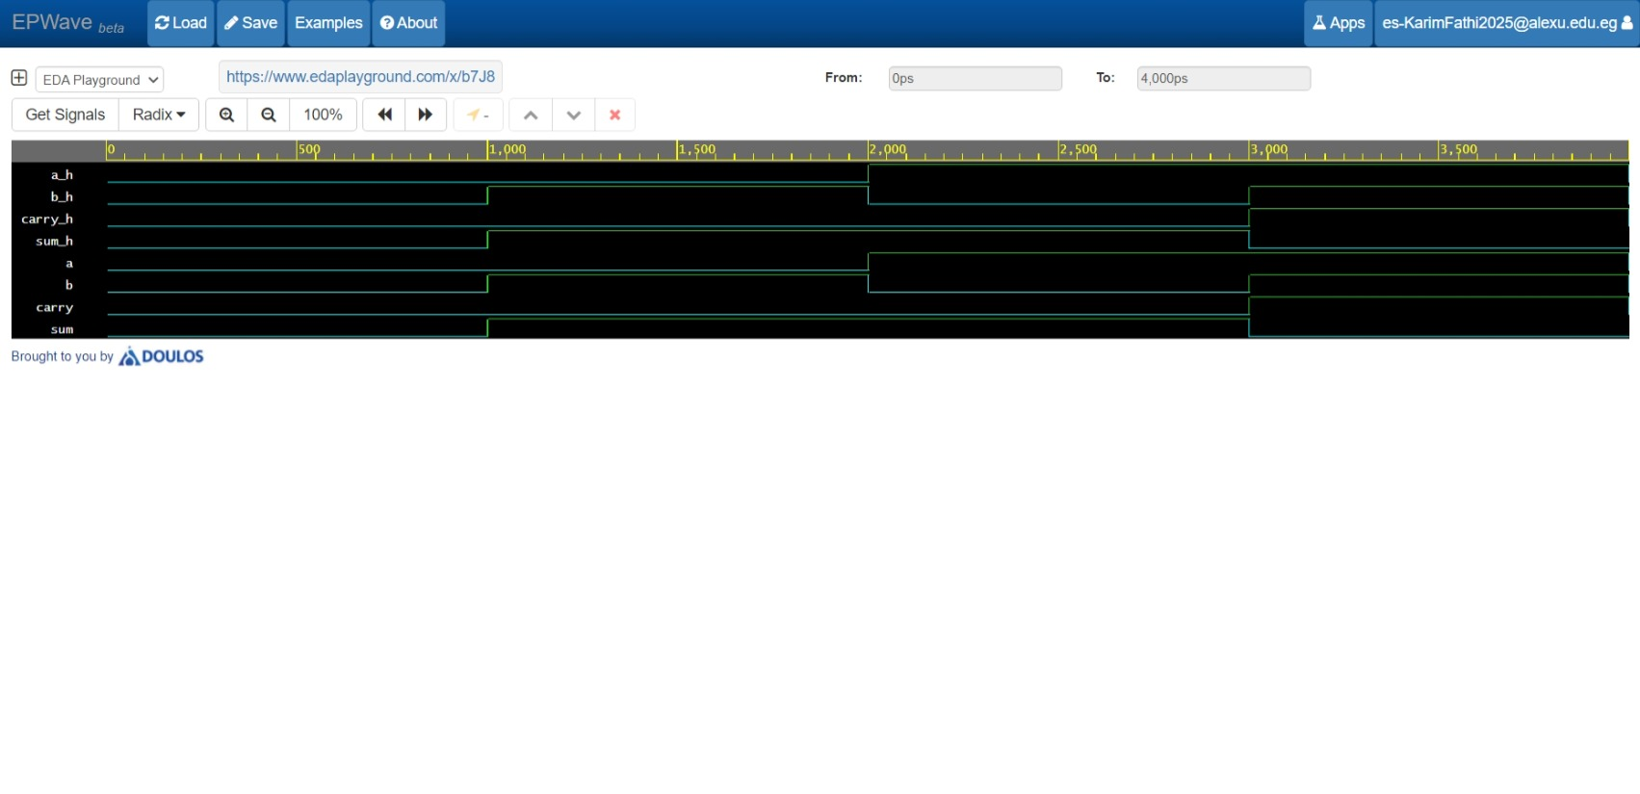
- half adder:

- full adder:
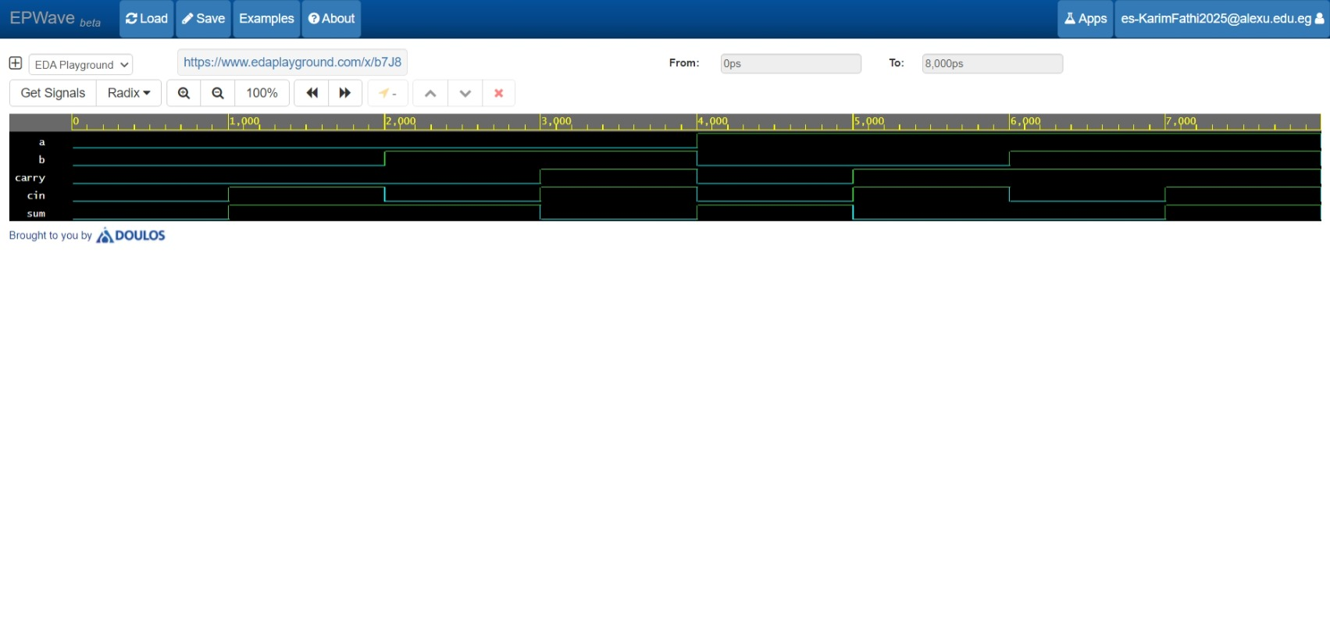

- ripple adder/subtractor:
1- adding:
2-subtracting:
3.code snippets:
- half adder:
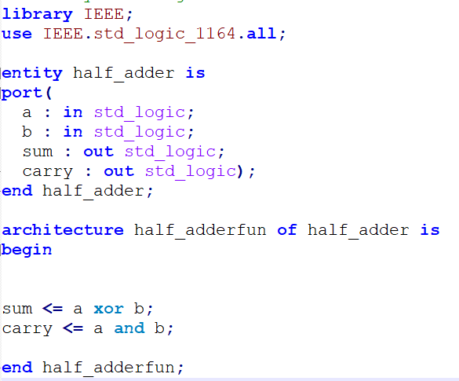

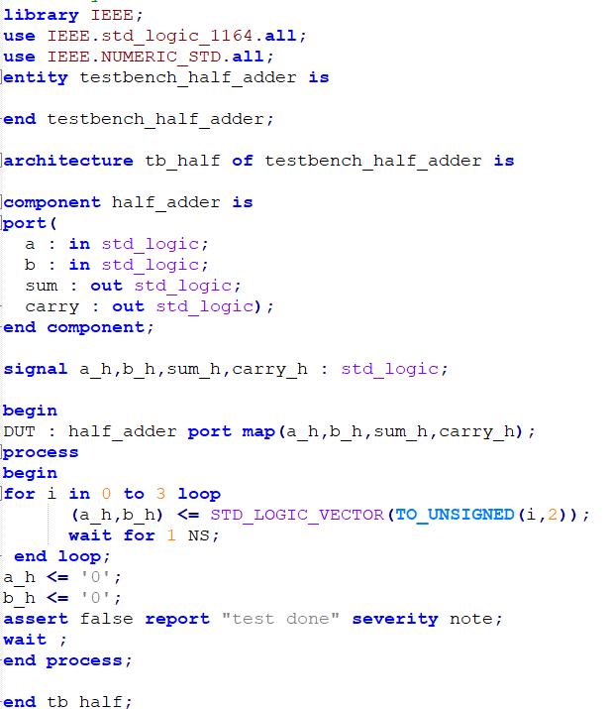
It’s test bench:
- full adder:
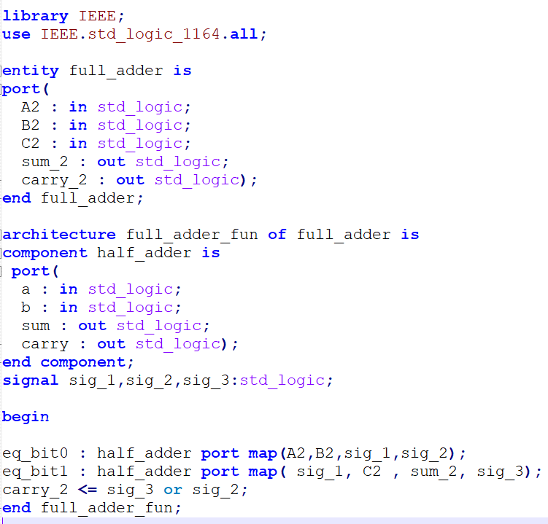

It’s test bench:
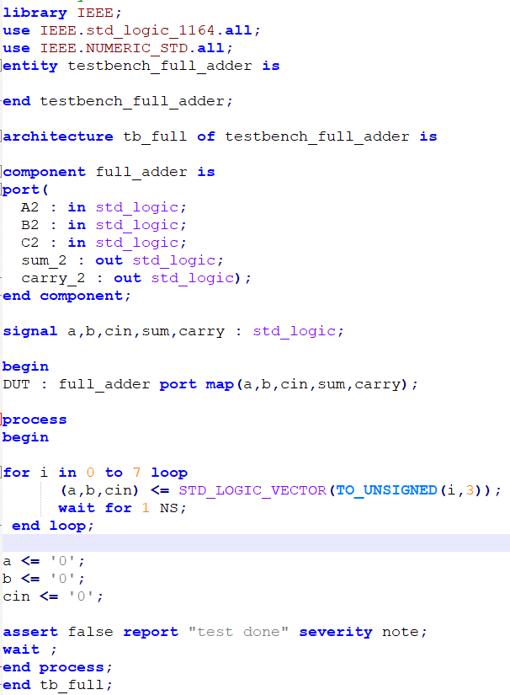
- ripple adder/subtractor:
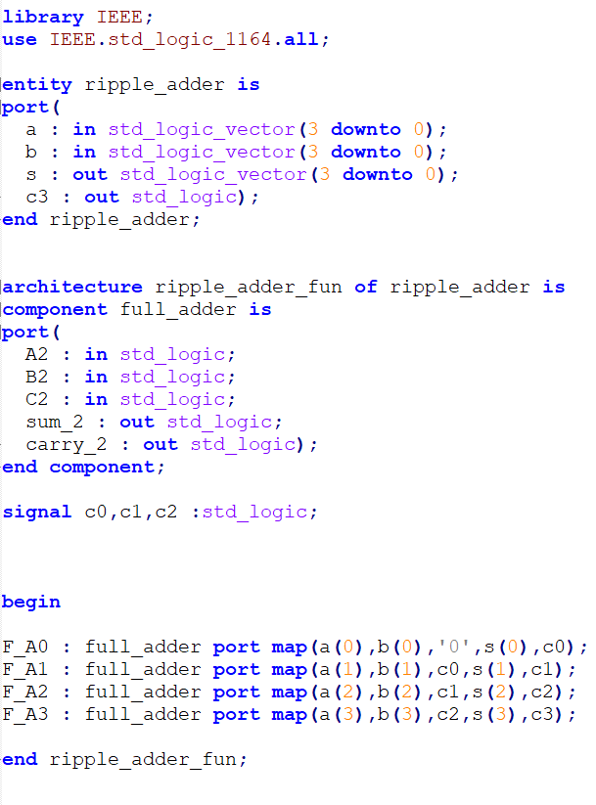
1-adding:
It’s test bench:
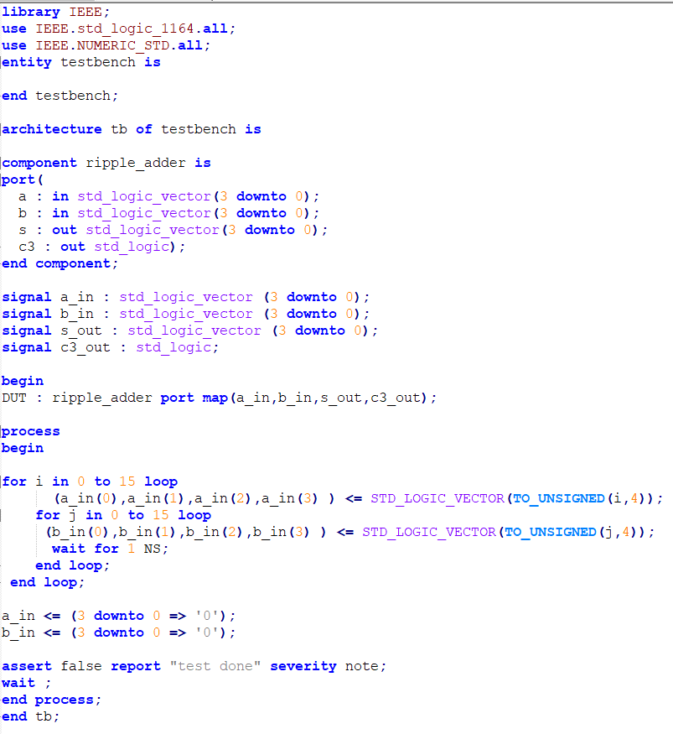

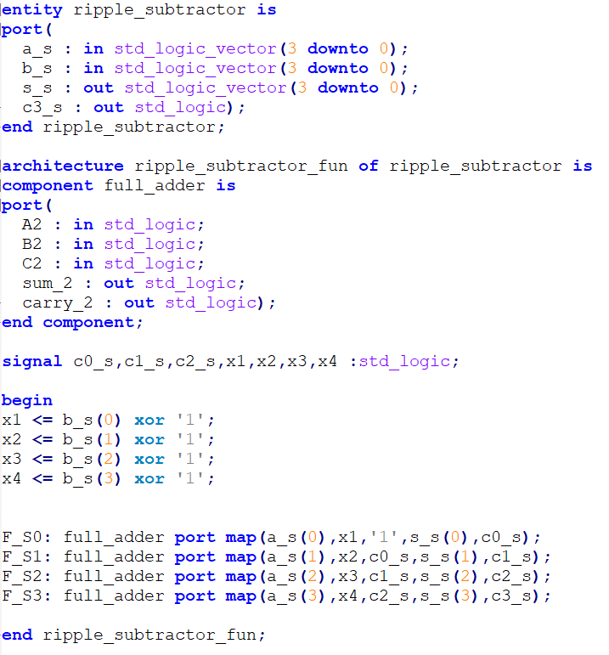
2-subtracting:
It’s test bench:
